Assignment 1.2

User Persona
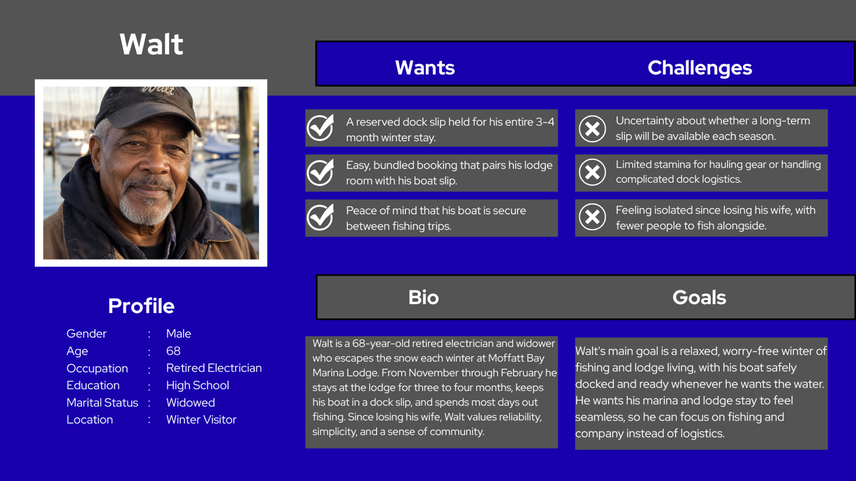

User Stories
- As a winter dock guest, I want to reserve a dock slip for a full 3–4-month block in one transaction, so I don’t have to re-book or risk losing my spot month to month.
- As a guest who is older, I would prefer to select a dock slip that is closer to the shore, so I don’t have to haul my equipment as far when I take it to and from the lodge.
- As a long-term slip holder, I would like clear, upfront pricing for a multi-month stay, including any seasonal or long-term discounts, so that I can budget for the winter without surprise fees.
- As a boat owner staying through long periods of time, I want information on what happens during inclement weather, such as procedures, safety, and insurance information.
- As a boat owner and slip holder, I would like the option to have marina staff check on my boat for me if I’m going to be gone for extended periods of time.
OpenAI. (2026). Portrait of Walt at a marina [AI-generated image]. ChatGPT.

